Link to Repository: https://github.com/SYnthestic/INF1103lab2
Docker Mount Success (Initialise) | 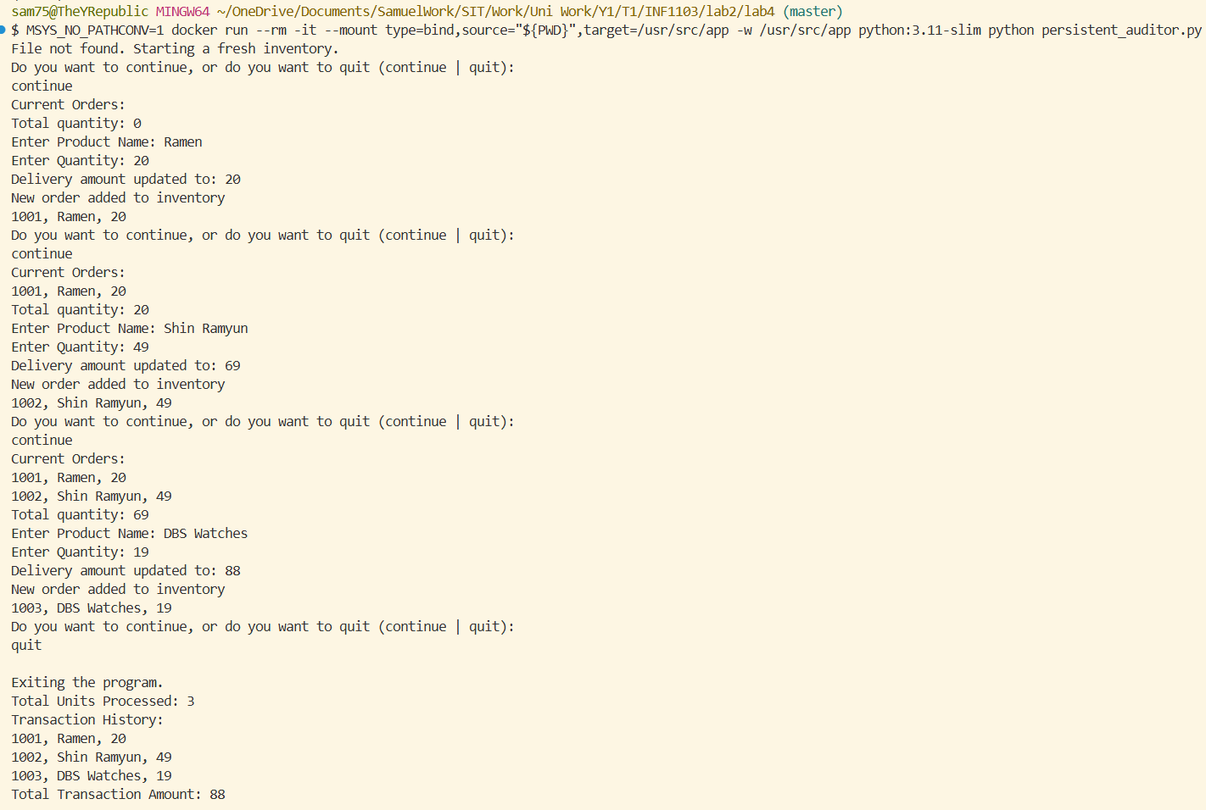
Docker Mount Success (Resume) | 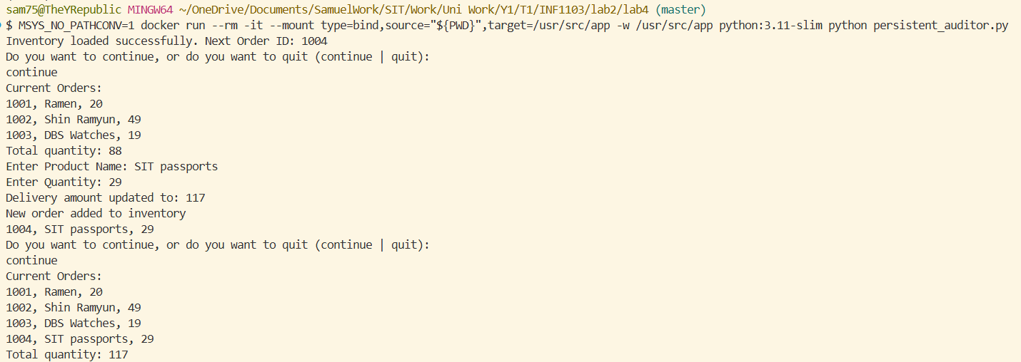
Docker Build Image | 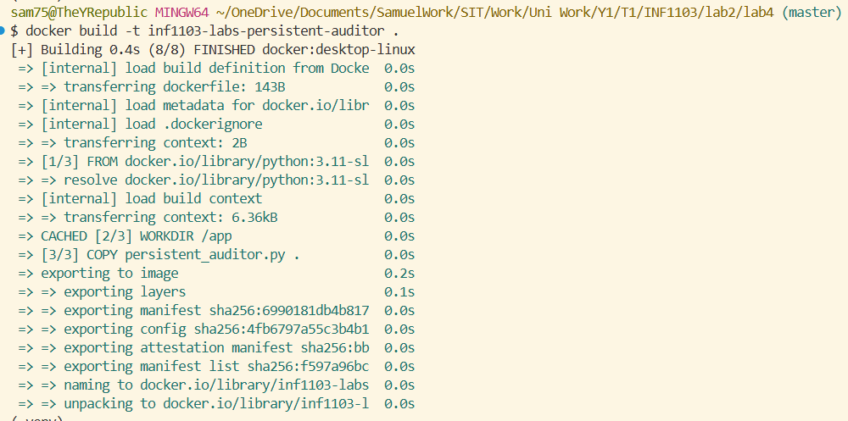
Docker Image Build Success (Initialise) | 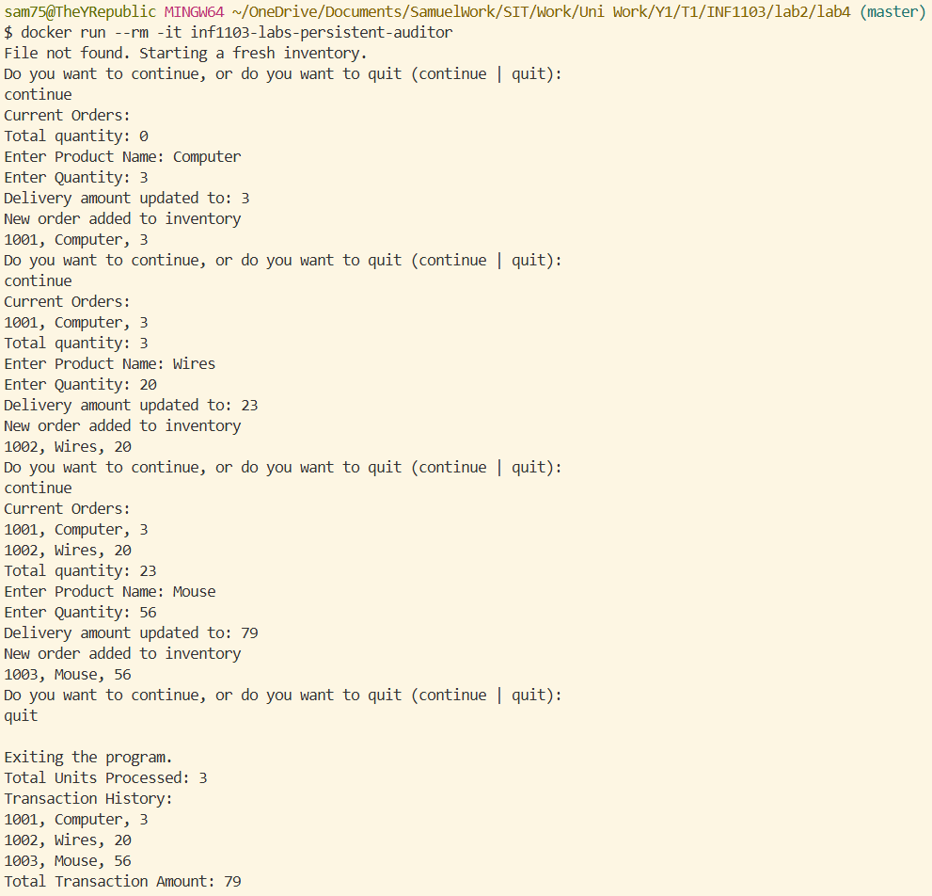
Docker Image | 